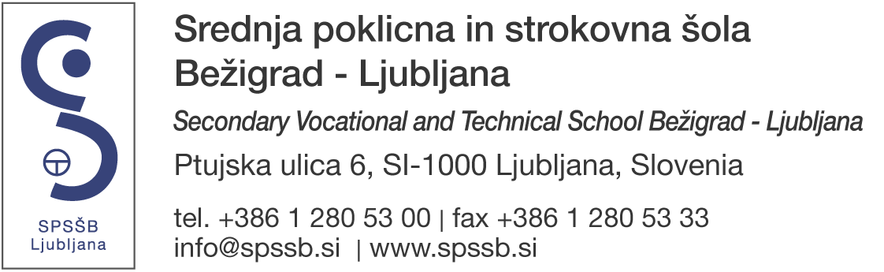

Srednja poklicna in strokovna šola Bežigrad – Ljubljana
Secondary vocational and technical school Bežigrad – Ljubljana

D.x Partner Organisation

PIC: 948710150
Email: info@spssb.si

D.x.1. Profile

Type of Organisation: School/Institute/Educational centre – Vocational Training (secondary level)
Total number of staff: 110
Total number of learners: 1050 students, 800 adults

D.x.2. Background and Experience

Please briefly present the partner organisation (e.g. its type, size, scope of work, areas of specific expertise, specific social context and, if relevant, the quality system used).

SPSŠB Ljubljana is a vocational and technical school, founded in 1962, which prepares students to enter the labour market or continue their education. It provides programmes in the fields of logistics, textile and mechanical engineering. The following courses are offered:
- Short-cycle vocational education - 2 years: Assistant in Technology Processes, Textile Reworker;
- Vocational secondary education - 3 years: Car Mechatronic, Vehicle Body Repairer, Industrial Mechanic, Metal Sharper-Tollmaker, Tinsmith-Roofer, Dressmaker;
- Vocational-technical education - 3 + 2 years: Mechanical Engineering Technician, Automotive Service Technician, Technician of Mechatronics, Logistics Technician, Creator of Fashion Clothing;
- Technical secondary education (4 years): Logistics Technician, Creator of Fashion Clothing.

Approximately 1050 students and 800 adults are enrolled each year.

In the last ten years, the school has been actively involved in the process of renewal of vocational and technical education in Slovenia, with a strong emphasis on mastering the key competences and in the light of closer cooperation between education and the labour market. The school has acquired a wealth of experience, which helped in the development of modern didactic and pedagogical approaches.

The school offers unique and exciting learning opportunities by working closely with craftsmen and many different companies. In addition to the regular educational programme, the courses for adult education are carried out as well. There are additional two organisational units being part of the organisation: Driving school Ježica with training for all driving categories and Intercompany Education and Training Centre (MIC), offering a key link between education and the labour market. All efforts of the organisation are aimed at making a better future for students and trainees.

KA2: What are the activities and experience of the partner organisation? What are the skills and/or expertise of key persons involved?

As a pilot school for the introduction of new programmes in the Slovenian education system, SPSŠB Ljubljana has gained extensive experience on new didactic and pedagogical approaches to teaching in the renewed vocational secondary school programmes. School has been actively involved in the reform of VET programmes, with learning process focused on acquiring key competences. It also many years of experience in the field of cooperation in international, national and bilateral projects, as confirmed by both national and European awards. In 2015 school also acquired Erasmus+ VET Mobility Charter, which indicates high level of quality and strategic approaches in mobility projects.

Key teachers and educators are still actively involved in previous projects. They all have vast experience in international activities.

KA1: What are the activities and experience of the organisation in the areas relevant for this application?

For a decade SPSŠB Ljubljana has either been coordinating or taking part as a partner in many international projects. One aim of school’s international strategy is to increase student and staff exchanges. About 30 students and 20 experts are sent abroad each year. About the same number of students and staff members are also received from partner organisations. Our exchange students have their practical training either in the partner institution workshops or at foreign companies, the same as foreign students who can either train in different workshops at school or/and are sent to work placements in local companies. The aim of schools’ international strategy is also to give all the students the possibility to gain international skills during their exchange period; the most effective way is working in an international project and having a possibility to travel abroad to meet other students in partner schools. The students also improve their language skills by being encouraged to speak foreign languages.

KA1: Please give information on the key staff/persons involved in this application and on the competences and previous experience that they will bring to the project.

There are four staff members working on mobility projects: two project coordinators are responsible for sending our students and teachers abroad and two project coordinators for the reception of foreign students and teachers. They all have vast experience in such projects. In addition, the teachers from each field – engineering, textile and logistics department, are responsible for taking care of students coming from abroad. All of them have organisational experience in preparing a programme for foreign students, covering their work at school and/or work placement and free time cultural activities.

Has the partner organisation participated in a European Union granted project in the years preceding this application?
Yes
Leonardo da Vinci 2013 LDV-MOB-23/13 SPSŠB
Leonardo da Vinci 2013 LDV-MOB-89/13 SPSŠB
EGP/NFM 2013 NFM-NFM-33/13 SPSŠB
Erasmus+ KA1 2014 KA1-VET-184/14 SPSŠB
Erasmus+ KA2 2014 KA2-SE-79/14 MEADOWHEAD SCHOOL ACADEMY TRUST, UK
EGP/NFM 2014 NFM–NFM–26/14 SPSŠB
Erasmus+ KA1 2015 KA1-VET-33/15 SPSŠB
VET Mobility Charter 2015 AKR-VET-13/15 SPSŠB
Erasmus+ KA1 2016 KA1-VET-33/16 SPSŠB
Erasmus+ KA2 2016 KA2-SE-73/16 Gymnasium Marne, DE
Erasmus+ KA1 2017 KA1-VET-44/17 SPSŠB
Erasmus+ KA2 2017 KA2-VET-23/17 University of Ljubljana, SI

D.x.3. Legal Representative

Title: MSc
Gender: Female
First Name: Frančiška
Family Name: Al-Mansour
Department:
Position: Headmistress
Email: fani.al-mansour@spssb.si
Telephone 1: +386 1 280 53 00

D.x.4. Contact Person

Title:
Gender: Male
First Name: Žiga
Family Name: Vuk
Department:
Position: Project coordinator
Email: ziga.vuk@spssb.si
Telephone 1: +386 1 280 53 19

